Unit 5A - Civil War & Reconstruction

People: Union (North)
 | Image | What they were | Why they were important
Republican Party | 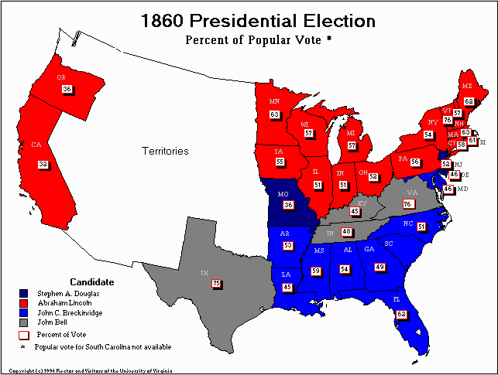 | Political party started when Dem-Rep broke off to form own group | Formed because  Dem-Rep Party could not agree about slavery  Signified how divisive (didn’t agree) country was because of slavery
Abraham Lincoln | 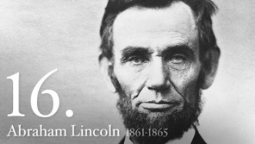 | President of US | Kept country together  Abolished slavery
Ulysses Grant | 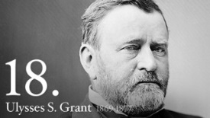 | Union General | Won war for Union
William T Sherman | 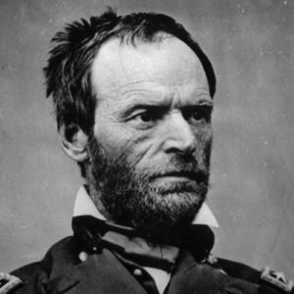 | General - north | Burned Atlanta

People: Confederacy (South)
 | Image | What they were | Why they were important
Jefferson Davis | 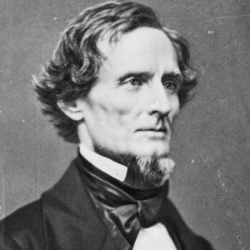 | President of Confederacy | Never established unified government in South
Robert E Lee | 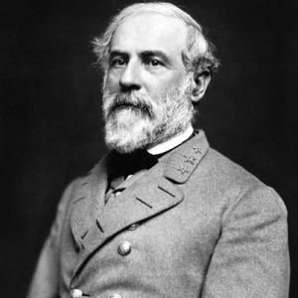 | Confederate General | Led Confederate troops
Thomas “Stonewall” Jackson | 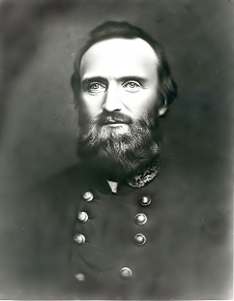 | General - South | Known as Robert E Lee’s ‘right-hand man’

Events
 |  | Image |  | What they were |  | Why they were important
Nullification |  | 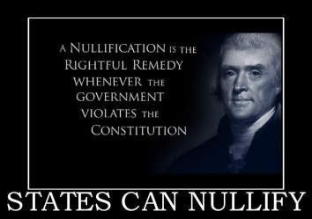 |  | Idea that states don’t have to obey fed laws if they don’t want to |  | South felt that they were not required to follow laws that they did not like
Compromise of 1850 |  | 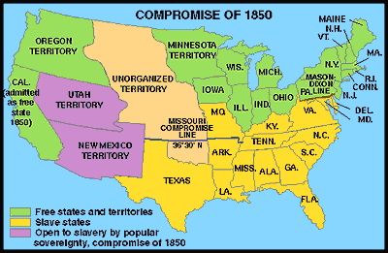 |  | Decision on  how to use land from  Mexican-American War |  | Opened up Utah & New Mexico to popular sovereignty  Slavery issue still unresolved
Uncle Tom’s Cabin  1851 |  | 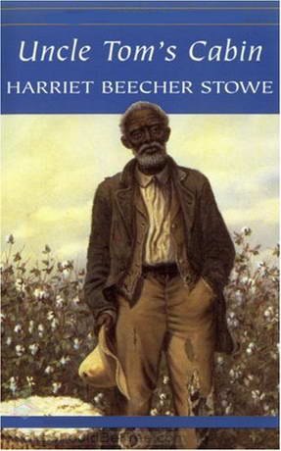 |  | Book that told about slavery horrors |  | Brought attention to  abuse of slaves
 | Kansas-Nebraska Act  1854 |  | 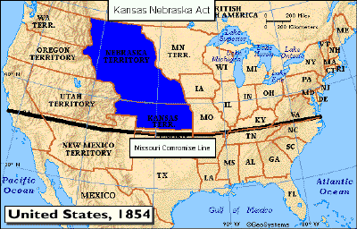 |  | Decision on how to use land from Louisiana Purchase |  | Opened up Kansas & Nebraska to popular sovereignty  Made political struggle for territories to become slave  ‘Bleeding Kansas’  years of fighting & riots
 | Popular sovereignty |  | 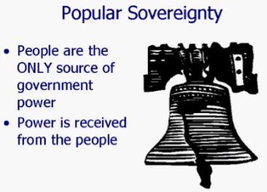 |  | Idea that people in the territory/state can decide whether or not to have slavery |  | Avoided conflict of slavery by giving power to settlers  Indirectly encouraged conflict by political interest groups
 | Dred Scott Decision  1857 |  | 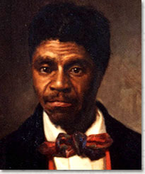 |  | Court decision that said slaves could not sue in court since they were property & not citizens |  | Court ruling stated that Congress did not have constitutional right to make laws regarding slavery  Made popular sovereignty legislation ineffective
 | Secession  1861 |  | 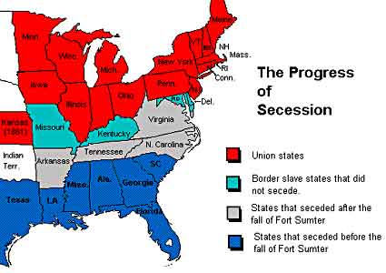 |  | Southern states ‘leave union’ - become a different country |  | Eventually leads to  Civil War
 | Habeas Corpus  May 1861 |  | 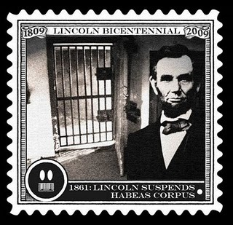 |  | Right to know why you are being arrested  Cannot be jailed/detained without knowing reason |  | Lincoln ‘suspends’  (does not follow)  HC during Civil War to keep Maryland part of Union  (DC would be capitol in another country  if MD left)
 | Emancipation Proclamation  Jan 1863 |  | 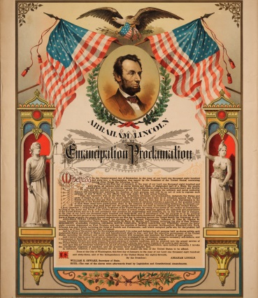 |  | Legislation that freed slaves in states in rebellion |  | Keeps Kentucky from leaving the Union
 | Gettysburg Address  Nov 1863 |  | 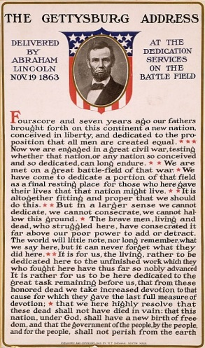 |  | Speech Lincoln gives to honor soldiers killed |  | Offers respect to both sides - North & South
 | 2nd inaugural address  1865 |  | 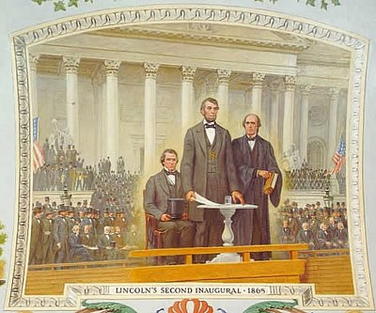 |  | Speech Lincoln gives at beginning of term |  | Wants to unify the country - not punish the South

Battles
 |  |  | Image |  | What they were |  | Why they were important
Fort Sumter |  |  | 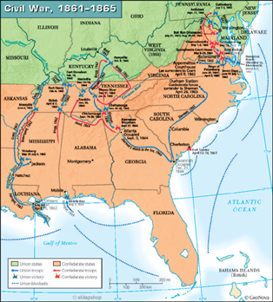 |  | Military fort in  harbor off SC |  | First battle of Civil War  South attacks North
 | Antietam |  |  | Battle in Maryland |  | Very bloody  After this, Lincoln gives Gettysburg Address
 | Vicksburg |  |  | Battle at Mississippi which took over control of Mississippi River |  | North cut off  Mississippi River
 | Gettysburg |  |  | Battle in Pennsylvania |  | Bloodiest battle  South becomes on the defensive
 | Pickett’s Charge | 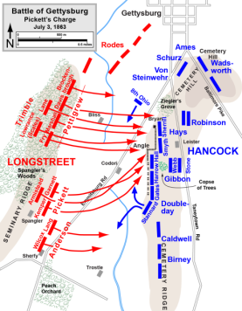 |  | Last battle at Gettysburg |  | Strong but failed attack  Shows South they can be defeated
 | Battle for Atlanta |  |  | Last major battle in South |  | Railroads/supply line for South destroyed  South burned after battle from Atlanta to ‘the sea’ (Savannah)
 | Appomattox |  |  | Town in Virginia |  | Location of  Robert E Lee’s surrender

Unit 5B - Reconstruction
Events
 |  |  |  | Image |  | What they were |  | Why they were important
 | Homestead Act  1862 |  |  | 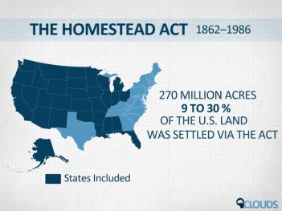 |  | Gave western land away to anyone who had never fought against the Union |  | Encouraged settlement of the west to those loyal to the Union
 | 10% Plan  Dec 1863 |  |  | 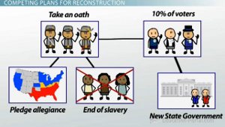 |  | Southern state could become part of US again when 10% of voters ‘swore allegiance’ (promised to be faithful) to Union |  | Readmitted South  to Union quickly
 | Reconstruction  1865-1877 |  |  | 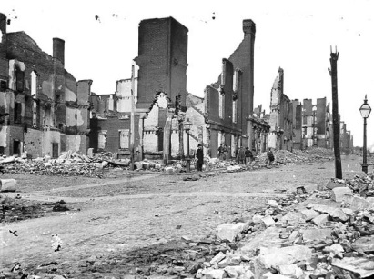 |  | Time period after Civil War when country rebuilt |  | Reestablished  government in US
 | Carpetbaggers |  |  | 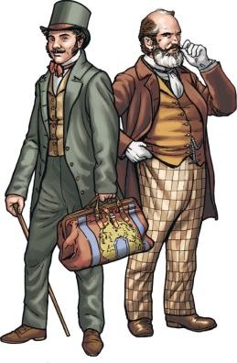 |  | People from the North who came down South to profit from South’s weak economy |  | Showed how weak South’s economy was
 | Scalawags |  |  |  |  | Southerners who supported Republican party |  | Showed divisiveness of South in politics
 | Presidential Reconstruction  1865-1869 |  |  | 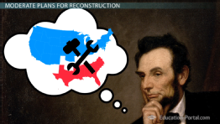 |  | Lenient policy to readmit South to the Union |  | Was meant to unify country through leniency towards South, but did not allow for AA transition to society under Johnson
 | 13th Amendment  1865 |  |  | 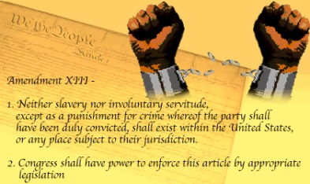 |  | Abolished slavery |  | Slavery was no longer a legal practice in the US
 | Ku Klux Klan  1865 |  |  |  |  | White supremacy group in the South |  | prevented AA vote  through intimidation
 | Black Codes  1865 |  |  | 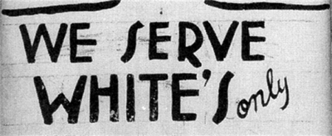 |  | Laws made by Southern states to deny AA rights |  | Limited AA opportunities in the South
‘40 acres and a mule’  1865 |  |  | 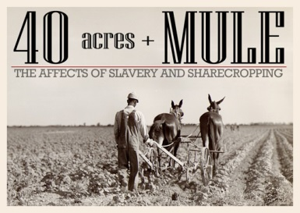 |  | Land & mule given to AA during Civil War, then taken away |  | Foundation for sharecropping  (AA work land in exchange for rent & low wages)
Morehouse College  1867 |  |  | 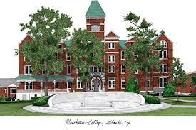 |  | College for AA in Atlanta |  | First college for AA  in the US
Freedman’s Bureau  1865-1872 |  |  | 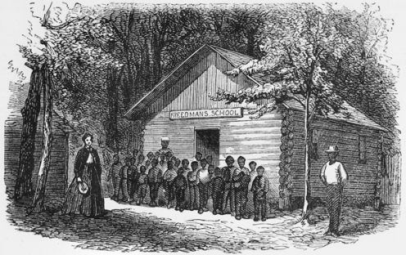 |  | Organization created to assist AA with employment and housing |  | Helped AA transition into free society
Tenure of Office  Act  1867 |  |  | 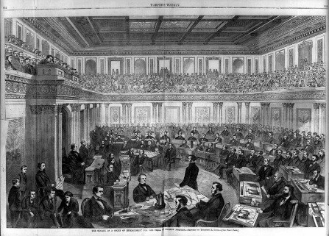 |  | Legislation that said president had to get approval before firing Cabinet members |  | Allowed for removal of Andrew Johnson from office  Congress then controlled reconstruction efforts
14th Amendment  1868 |  |  | 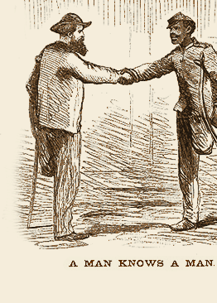 |  | Change to the Constitution that gave equal rights to all men, regardless of race |  | AA could have government protection and citizenship
Congressional Reconstruction  1869-1877 |  |  | 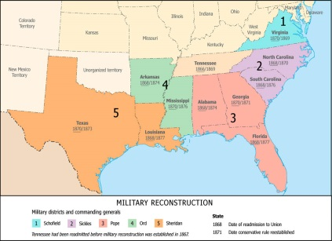 |  | Strict policy to readmit South to Union  Made up of Radical Republicans in Congress |  | Was meant to punish the South, but also help AAs transition into society
Transcontinental Railroad  1869 |  |  | 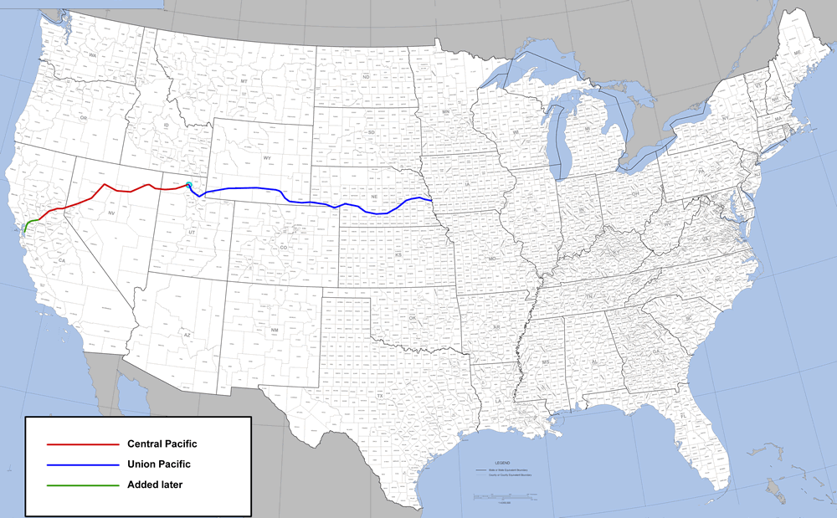 |  | Railroad built across US |  | Made western migration much easier  Helped settle  the Western US
15th Amendment  1870 |  |  | 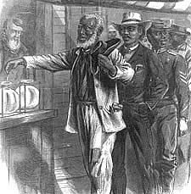 |  | All men allowed to vote, regardless of race |  | Gave blacks the right to vote
Battle of Little Big Horn  1876 |  |  | 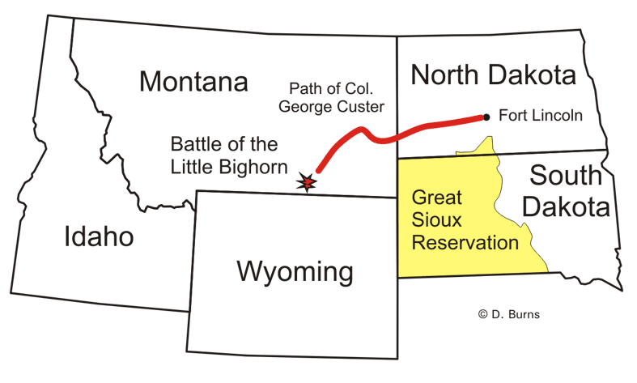 |  | Native victory in the West |  | Biggest US defeat by natives  Gave natives hope of preserving their lands
General George Custer |  |  | 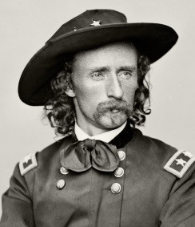 |  | US general at Battle of Little Big Horn |  | His defeat showed US govt that natives could overpower them and more troops were needed
Compromise of 1877 |  |  | 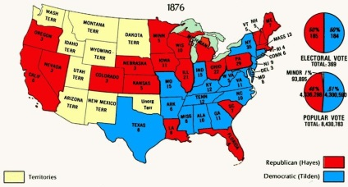 |  | Resulted from  tie in Election of 1876  Rutherford B Hayes  wins presidency |  | Ended Reconstruction  Removed federal troops from South
Jim Crow Laws  1877-1965 |  |  | 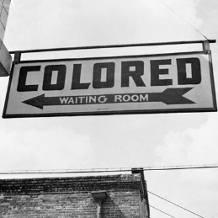 |  | Laws segregating facilities in the South |  | Kept racial discrimination legal in South
 |  | Battle of Wounded Knee  1890 |  | 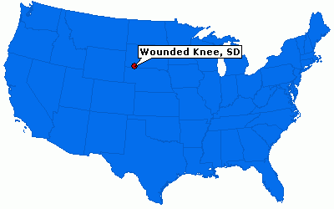 |  | Massacre of Plains natives |  | Last struggle btwn  US govt & natives
 |  | Sitting Bull |  | 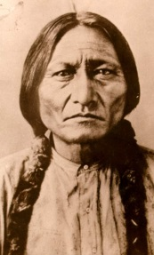 |  | Sioux leader who tried to keep native lands in West |  | Symbol of loss of native western lands
 |  | Plessy vs Ferguson  1896 |  | 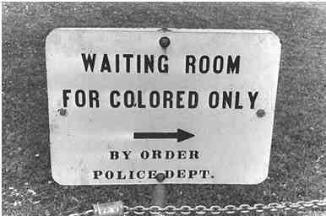 |  | Court case that said facilities for AAs should be ‘separate but equal’ |  | Said that blacks could have same facilities as whites, but could not use same facilities  Kept racial discrimination legal in South

Unit 6 – Expansion, Industrialization, & Immigration

People
 | Image | What they were | Why they were important
Andrew Carnegie | 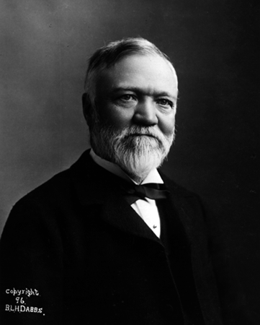 | President & founder of Carnegie Steel Company | Made mass production of steel possible  Develops concept of horizontal consolidation  – owns all parts of production
John D. Rockefeller | 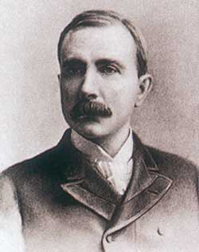 | Presidents & founder of Standard Oil Company | Makes monopoly  Control market through vertical consolidation  – buy competitors
Thomas Edison | 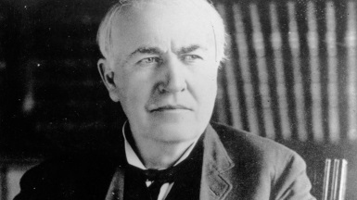 | Inventor of light bulb, phonograph  (record player),  motion picture (movies) | Makes life at night possible  Working hours can increase to overnight
Samuel Gompers | 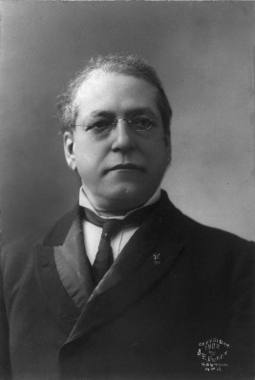 | President of American Federation of Labor (AFL)  Uses strikes to achieve rights for workers | Makes workers more powerful  Increases wages, decreases work hours
Ida Tarbell | 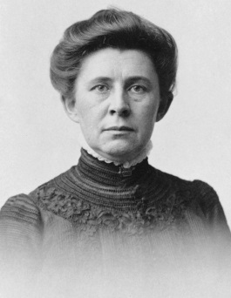 | Muckraker  brought attention to Standard Oil Company’s practices, which eventually dissolved the company | Showed that journalists had power to dissolve businesses if practices were unfair

Groups of People
 | Image | What they were | Why they were important
Robber Barrons | 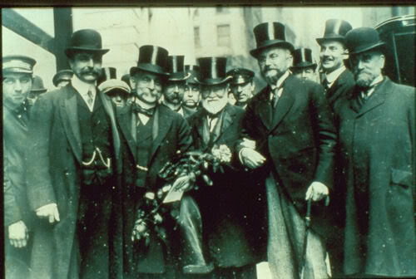 | Negative term for wealthy businessmen | Greatly took advantage of average industrial worker
Captains of Industry | 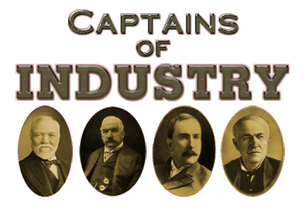 | Positive term for wealthy businessmen | Greatly improved wealth of the US
Populist Party |  | Political party during Progressive Era  “People’s Party”  Represented farmers | Brought attention to plight of farmers
NAACP | 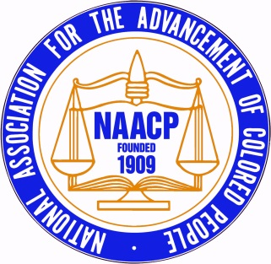 | National Association for the Advancement of Colored People  Organization for  life improvement of African Americans | Seeks full civil rights for African Americans
Muckrakers | 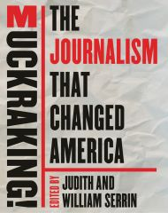 | Investigative journalists | Exposed unfair practices to better life for individuals

Places
 |  | Image | What they were | Why they were important
Ellis Island |  | 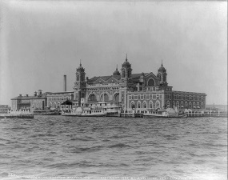 | Island  Immigration processing center for European immigrants | Brought in many European immigrants in early 1900s  Disallowed diseased persons to enter, even though NYC had large amount of disease
Hull House |  | 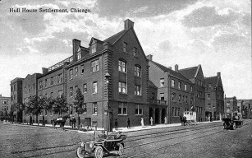 | Settlement house for new immigrants | One of first  social services in US
National Parks | 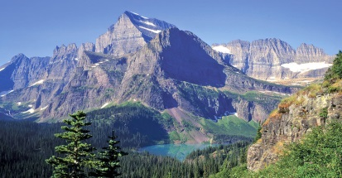 |  | Land set aside by  Teddy Roosevelt | Land still exists today undeveloped – encourages future tourism

Events
 | Image | What they were | Why they were important
Pullman Strike | 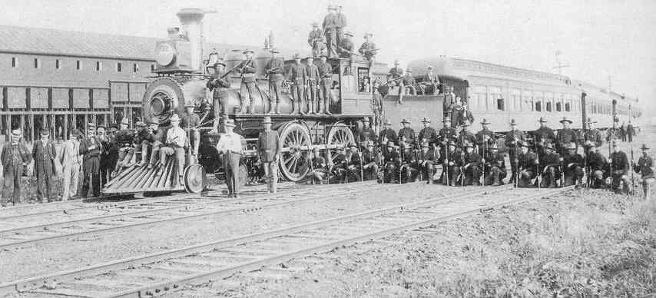 | Strike by railroad workers  Led by ARU  – Eugene Debs | First time federal govt involved in strike – mail on trains
Conservation Movement | 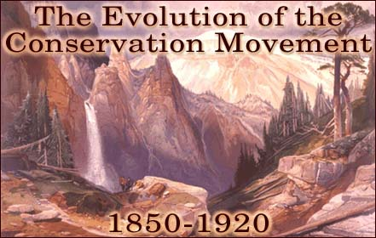 | Social movement to set aside land for national parks | Establishes national parks

Ideas & Concepts
 | Image | What they were | Why they were important
Causes of Industrialization | 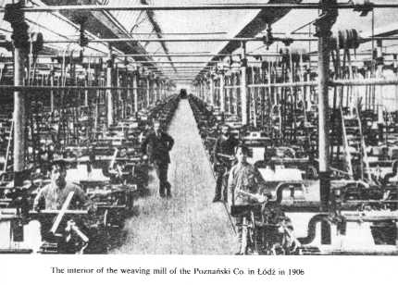 | Railroads, steel,  oil, electricity | Makes production greatly increase in US economy
Corporation | 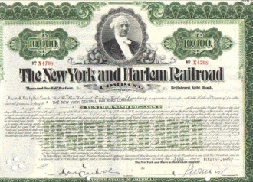 | 2 or more partners in a business  Railroads – first corporations | Reorganized businesses from unstable partnerships to large-scale companies  Makes uneven distribution of wealth
Monopolies | 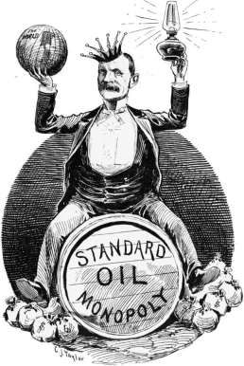 | One company controls the market  Standard Oil – first monopoly | Draws attention to how monopolies can unbalance US economy
Trusts | 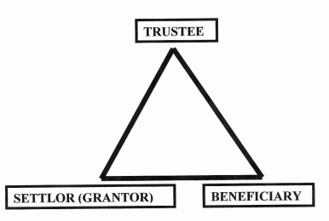 | Type of legal situation where another party is responsible for money of a company | Monopolies become ‘trusts’ after they are made illegal  Retrains trade
Social Darwinism | 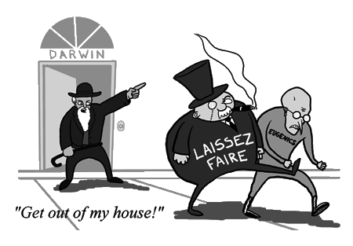 | Idea that the strong people of a society will & should survive | Leads to negative sentiment (feelings) of social welfare programs
Initiative | 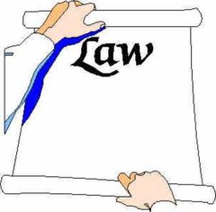 | Idea that the people should propose laws, not just Congress | Gets the public directly involved with lawmaking
Recall | 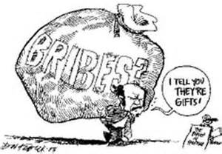 | Idea that if an elected official has committed a serious crime, they should be ‘recalled’ from office | Stops/slows corruption in politics  Stops/slows bribing of politicians to ignore enforcement of laws
referendum | 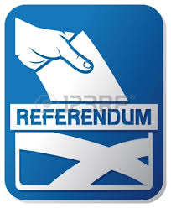 | Proposed legislation should be voted on | Tests the public’s feeling on if laws should be discussed in Congress

Legislation

 | Image | What they were | Why they were important
Jim Crow Laws | 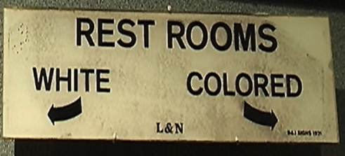 | Laws that segregated AA from whites | Did not allow for intermingling of races  Increased/Continued segregation & racist sentiments
Plessy vs Ferguson | 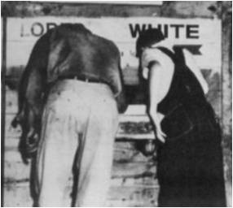 | Law that said Jim Crow laws were constitutional because AA were not denied rights | Reinforced idea that government would not fight segregation
Sherman Anti-Trust Act | 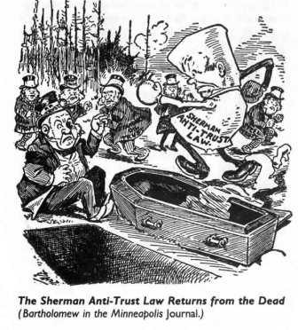 | Law that said trusts/monopolies were illegal | Not widely enforced  Later, T Roosevelt enforces it  Breaks up monopolies/trusts for good
Chinese Exclusion Act | 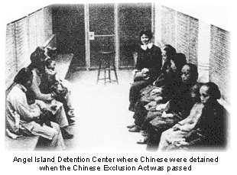 | Banned all future Chinese immigration | Excluded Chinese from migrating to US  Western European immigration encouraged in East – Chinese immigration discouraged in West

Publications
 | Image | What they were | Why they were important
The Jungle | 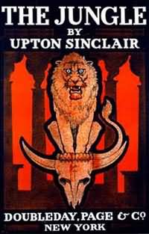 | Book that told uncleanly conditions of meat-packaging industry | Eventually leads to development of FDA (Food & Drug Administration)  FDA protects consumers regulating (making rules for) food industry

Unit 7 – Imperialism & World War I

People
 | Image | What they were | Why they were important
Eugene Debs | 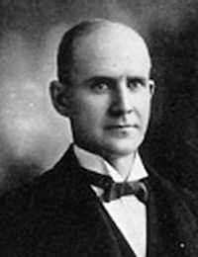 | Socialist Party presidential candidate  (1904, 1908, 1912) | Spoke out against military recruiting  Slowed military recruiting for WWI

Groups of People
 | Image | What they were | Why they were important
Rough Riders | 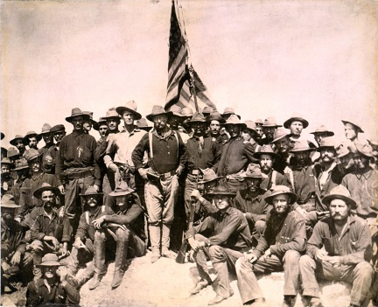 | Volunteer military in Spanish American War  led by Teddy Roosevelt | Spanish left Cuba after Rough Riders came in

Places
 | Image | What they were | Why they were important
Annexation of Hawaii | 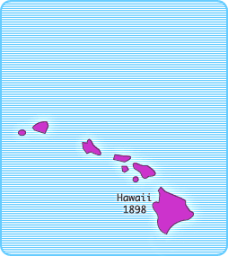 | Territory in Pacific Ocean  Became state in 1898 | Began international expansion of US territory
Panama Canal | 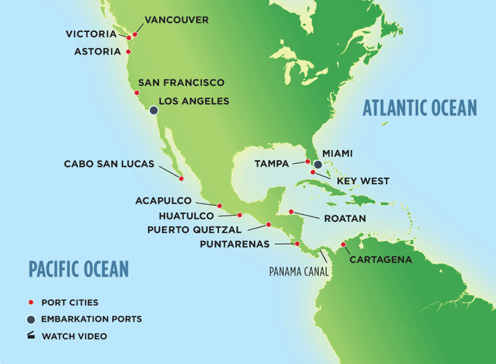 | Water route in Panama (Central America) | Made trade btwn western & eastern US much faster

Events
 | Image | What they were | Why they were important
Spanish American War | 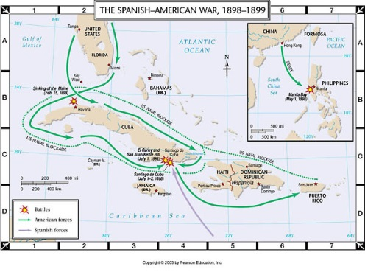 | War btwn US & Spain  Wanted  control of/independence for  Cuba, Puerto Rico, & Philippines | Expanded US territory

Ideas & Concepts
 | Image | What they were | Why they were important
Submarine warfare | 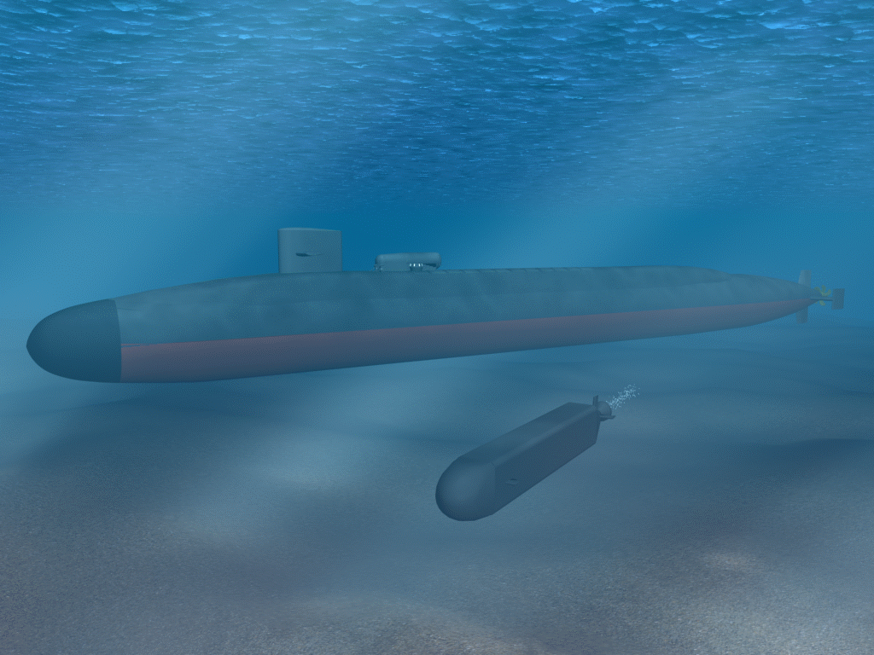 | War under the ocean with ‘submarines’  (boats under water) | Changed warfare  Easily attacked naval ships
Neutrality | 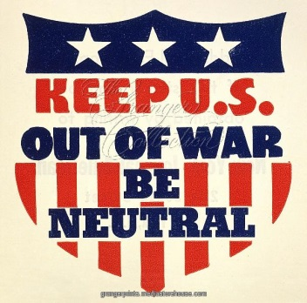 | Idea that war could be avoided if no side was taken | Kept US out of war at times
Zimmerman Message | 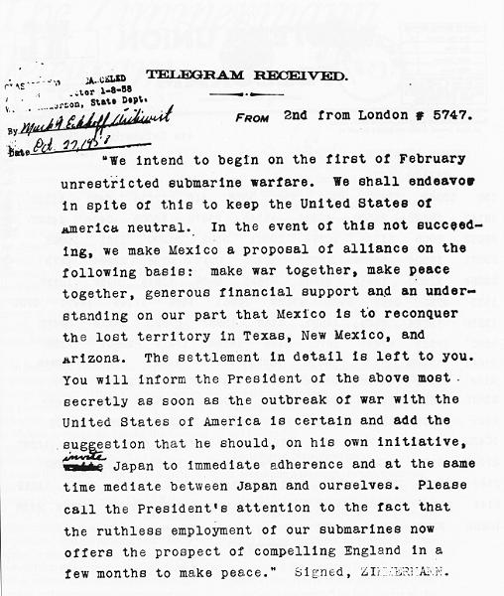 | Message sent btwn Germany &Mexico  Germany wanted to form alliance with Mexico  against US | Brought US into WWI
Trench Warfare | 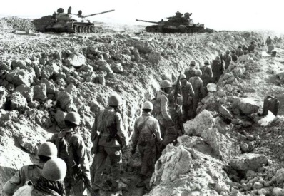 | Method of fighting using ‘trenches’  (deep paths  dug in the ground)  as protection | Changed battles  (before, soldiers lines up)  Made fighting more secretive
Great Migration | 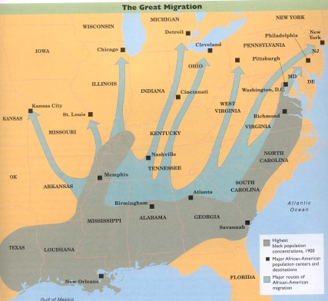 | Movement of  African Americans  from South to North | Shifted AA population from South to North

Legislation
 | Image | What they were | Why they were important
Roosevelt Corollary | 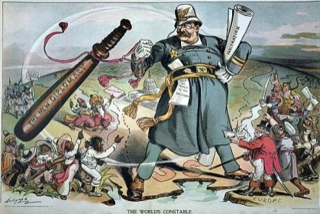 | Roosevelt’s idea that US could interfere with Europe if US economy was affected | Changed previous neutrality idea from Monroe Doctrine
Espionage Act | 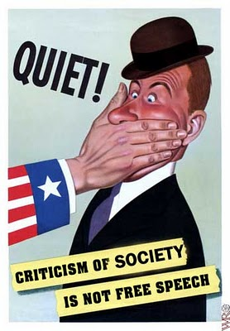 | Law that said people could not communicate in a way that would interfere with military | Went against freedom of speech  Made Americans suspicious of one another
Fourteen Points |  | Suggestions made by Woodrow Wilson  Wanted to improve communication between countries  Wanted to avoid future wars | Leads to formation of League of Nations
Treaty of Versailles | 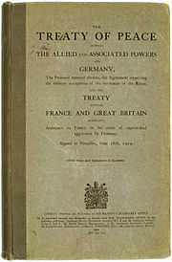 | Treaty that ended war between Germany & Allied Powers | US wanted reconciliation with Europe
18th Amendment | 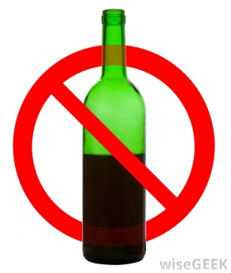 | Law that ‘prohibited’ (did not allow) alcohol | Came from feelings of resentment against German culture  (major producers of alcohol)
19th Amendment | 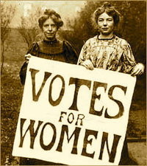 | Law that allowed women to vote | Brought about after women supported factories when men went to WWI

Ships
 | Image | What they were | Why they were important
Lusitania | 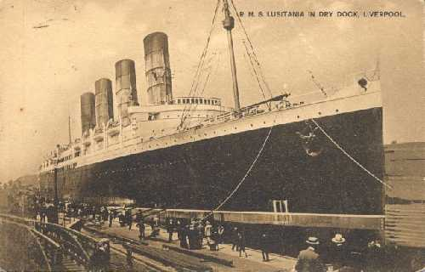 | ‘Luxury ocean liner’  (fancy boat for travel)  British ship sunk by German submarines | Had American passengers on board  (not military – rich people on vacation)  Made US start thinking about entering WWI

